## Part 1

## Signature Classification

### Reformatting Dataset Structure

* To Enable Tensorflow’s Data api to read the data properly the data was restructured From :  
   - Root  
   - class1  
   -Train  
   -Test  
   - class2  
   - Train  
   - Test  
   ..  
  To:  
   - Root  
   - Train  
   - class1  
   - class2  
   -...  
   - Test  
   - class1  
   - class2  
   -...  
  This structure allows keras to automatically read the files and infer the labels.

### Data Specifications

* Image Size: **(256, 256)**
* Color mode: **grayscale**
* Validation percentage: **20%**
* Images are **rescaled in range (0, 1)**

### Models

#### CNN1

Architecture:

[10x10 Conv, 8] [MaxPool] -> [5x5 Conv, 16] [MaxPool] ->   
 [3x3 Conv, 32] [MaxPool] -> [Flatten] [Dense,32] [Dense, 5 (softmax)]

Training Time ~ 4s & Testing Time < 1s **[GPU]**

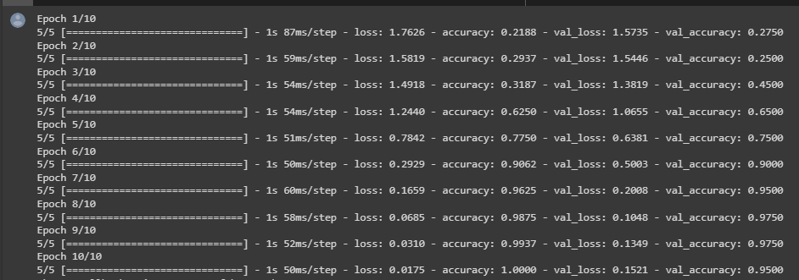

Results

### 

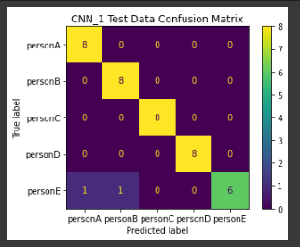

#### 

#### CNN 2 **(Choosen Model)**

Architecture:

[**3x3** Conv, 8] [MaxPool] -> [5x5 Conv, 16] [MaxPool] ->   
 [3x3 Conv, 32] [MaxPool] **[Dropout 0.2]** -> [Flatten] [Dense,32] [Dense, 5 **(ReLU)**]

Training Time ~ 35s & Testing Time ~1s

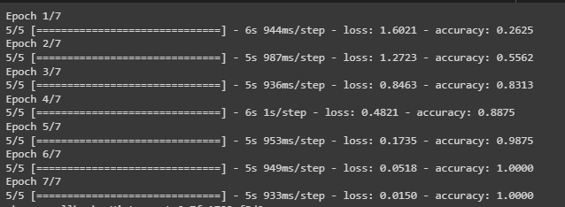

Results

### 

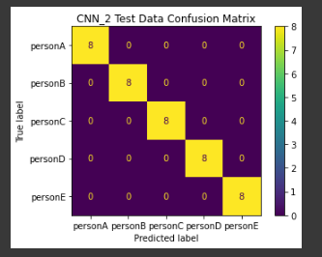

Test Set Sample

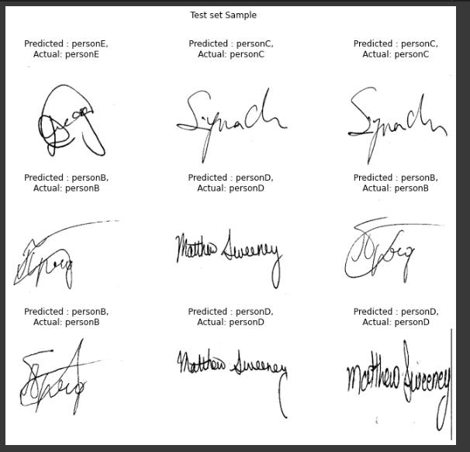

### Signature Verification

**Model:**

Architecture:

(three input layers [anchor - positive - negative] images of size (256,256,3)) -> (Xception architecture with average pooling) -> (Flatten layer) -> (Dense layer, 512, relu activation) -> (Batch normalization layer) -> (Dense layer, 256, relu activation) -> (Lambda, l2_normalization) -> (Distance layer).

Training & Testing time: 9s , 31 ms

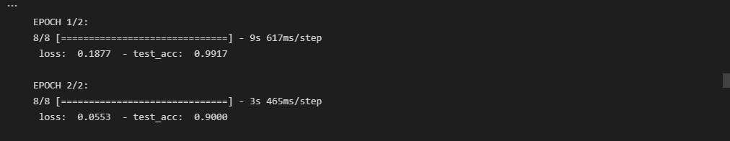

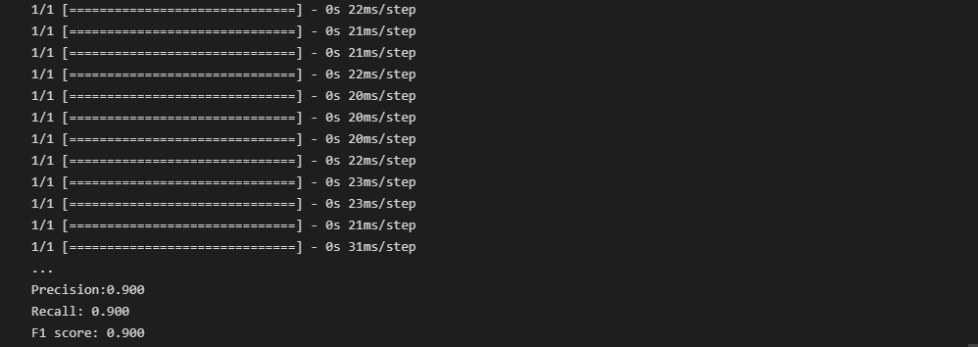

Results:

